Shell Windows

Intro

The purpose of this project is to port the main MS-Dos commands of the Microsoft Windows platform in a Unix/Linux environment.
This basically allowed to understand the correct usage of Linux/Unix system calls and so a quite deep knowledge of how a user program can require access to kernel functionalities. In particular the program aim to parse user-inserted lines, handle system calls, deal with files and directories.
Of course several changes were adapted mainly because file-path separator is different in Linux (‘/’ instead of ‘\’ of MS Windows) and options of commands in MS-Dos are introduced by ‘/’ symbol, that in the new environment this would make the detection of paths totally impossible (so options will be introduced by ‘\’ symbol here to avoid misunderstandings).
However commands “help” adapted to Linux environment are also provided, so that is easily possible to check the new correct syntax of the program.

A lot of effort was put in making commands behaviour as close as possible to their original one, but this wasn’t always 100% possible, mainly because we are dealing with completely different platforms.
The maximum effort have been done to fix all the bug and also to correctly handle memory and files by freeing allocated memory and closing opened file descriptors, when they are not used any more.

Core of program

The program structure is very simple and easily understandable, it can be described as an infinite loop, where the following steps take place:
- fork a new process
- parse a line inserted by user, distinguishing command and options
- execute the correct command; this means retrieve the correct function, which will receive options as parameters and handle requested command routines
- return control to parent process which is ready to execute a new command

Let’s say that this is an ideal behaviour, in fact this flow of execution can be interrupted in any time for different reasons; the aim is to replicate the common problems that a shell/terminal will handle while dealing with users command request, for example: problems with commands/options parsing (too many/few parameters, syntax errors), access denied to files, operations not permitted, non-existent resource.
Child and father process are able to communicate through a “pipe”, which is basically used when current working directory has changed as an effect of a command (typically after a “cd” command).

Then several variant are available respect to a “normal” command execution, the user can in fact request:

- “Redirection”
This means that the user is requesting the redirection of the output given by a command to a regular file. He can ask to store on a new file ―“<file_name>”— or to append to an existing file —“>> <file_name>”— (in case of non-existing file, it is created too). For sake of simplicity, both stdout and stderr are going to be redirected on the requested file.

This is achieved simply by closing the standard output (and stderr as well) file descriptor, which is holding the second row of the process’ file descriptor table, and substituting it with the retrieved file descriptor of the new file, which has been properly duplicated by using the dup( ) system call.
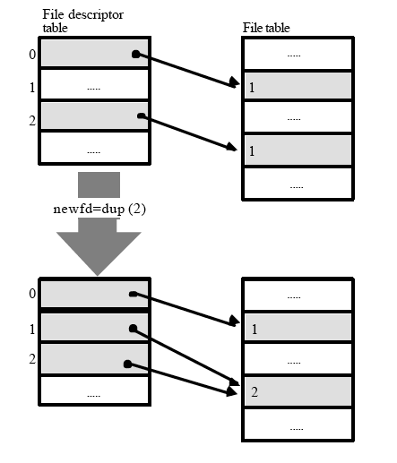

close(1); // close stdout
dup(fd); // duplicate fd -> this goes in the entry where there was stdout
close(2); // close stdout

dup(fd); // duplicate fd -> this goes in the entry where there was stderr
close(fd); // close original fd

- “Pipe”
This means that the user is typing two separate commands and requesting the redirection of the output of the first command as input of the following command, “<command> | < command>”.

This is achieved by using a “pipe”, shared among the two processes (that execute command routines) and creating a child while executing the first command. Then this command will close its stdout file descriptor (second row of the process’ file descriptor table), and substitute it with the writing part of the common pipe. The second command (here is the child process) will instead close its stdin file descriptor (first row of the process’ file descriptor table), and substitute it with the reading part of the pipe. Clearly in this way the first process is writing on the pipe and the other one is reading from it.

pipe(pipe_comm); // create pipe

// fork to distinguish between command before and after pipe
if ((pid=fork())==0) //first command just open pipe and then exec command normally
{
close(1);
dup(pipe_comm[1]); // use pipe as stdout
close(pipe_comm[1]);
}

else // second command after pipe
{
// wait end of first command
waitpid(pid, &status, 0);

close(0);
dup(pipe_comm[0]); // use pipe as stdin
close(pipe_comm[0]);

/* parse second command to be executed */
}
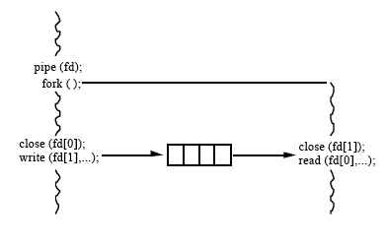
Let’s note that in this situation the last command is still able to request an output redirection, whereas of course this is not the case for the previous command.

Shared Library – PARSE.H

This library contains function that are commonly needed by all commands. These includes above all the function requested to parse a line inserted by user. Let's follow a sort of flow that will help to understand better how all these are needed. After the user prompted a command:
- the function getline( ) takes care of dynamically allocating a string of the right length;
- the function parse_command( ) is in charge of parsing the inserted line and separating the first string form the rest of the line, thus indicating to the program which is the command routine to execute.
- The function parse_options( ), will now parse the rest of the line, here a new custom data structure has been inserted:

typedef struct elem param;
struct elem
{
char *name;
int type;
param *next;
};

This structure will manage a linked list, where each element contains a string (in this context a string is intended has a sequence of symbols preceding a blank space in the line). So the parse_options( ) function is a key point of the program. It will parse the line, look for a new string, allocate a new element for each new string [new_elem()] , retrieve the kind of parameter parsed, distinguish among options or paths [jolly_char()] and finally insert this new element in a list [insert_e()]. This list is very important, each command will receive it as parameter and will scroll it to execute its routine and check parameters syntax or resource availability.
Furthermore the function parse_options( ) is also able to recall the correct routines when special characters are encountered (“>” or “>>” or “|”), redirector( ) and pipe_string( ).

Then there are several other routines used that are a mix of needed functionalities for checking syntax of paths alpha_num( ) and under_s( ), or to check if a directory is empty empty_dir( ), or to free in a consistent way memory allocated for a list my_free( ).

Commands

Copy
The purpose of this command is to copy files. In the MS-Dos this is able to manage only some situations of copy, such as:
- file-to-file
- dir-to-dir: in this case only if both directories exist, all the files contained in the source directory are copied into the destination directory, but avoiding subdirectories and their files
- concatenated_files-to-files: here a series of source file is appended one after the other in a destination file
All the other combinations are considered wrong.

The aim of the cp( ) function is first of all will scroll the p

Help / List
This is a trivial command that allow user to request the syntax of the behaviour of a specific command. The idea behind the helper( ) function is: take only one parameter as option (the command help requested) and by appending the .txt extension, look in the directory where help file are stored, and check if the file exist (so in this case the user is requesting help for an existing command), finally print the content of the relative help file.
Moreover the user can also type help without any argument, this is the same of typing list
and they both print to screen a list of available commands, through the listing( ) function.

